Project Title: Project Design Phase-I - Solution Fit Template Team ID: PNT2022TMIDxxxxxx

The customers of retail

Store are mostly from middle

Class background the main constraint is money

the products sold

Must be reasonable in their prices 1.transport : to provide delivery services

2.warehouse : to store stocks

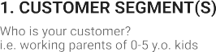

The major job is

to track the stocked many customers alter their changes in their behavior matters here a lot .

goods &The major problem decision due to their wishes in different products the seller must be polite with their customers

here is out of stock to sustain their customers.

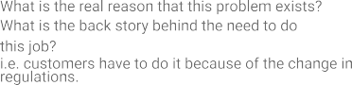

|  |  |  |  |  |
| --- | --- | --- | --- | --- |
|  | **3. TRIGGERS TR**  What triggers customers to act? i.e. seeing their neighbour installing solar panels, reading about a more efficient solution in the news.  Trigger is the minimum amount of inventory certain item can have before recorder | **10. YOUR SOLUTION SL**  If you are working on an existing business, write down your current solution ﬁrst, ﬁll in the canvas, and check how much it ﬁts reality.  If you are working on a new business proposition, then keep it blank until you ﬁll in the canvas and come up with a solution that ﬁts within customer limitations, solves a problem an d matches customer behavior  The foremost solution in any retail store inventory management is to build customer trust  And to satisfy their common customers . | 1. **CHANNELS of BEHAVIOUR CH**    1. **ONLINE**   What kind of actions do customers take online? Extract online channels from #7   * 1. **OFFLINE**   What kind of actions do customers take offline? Extract offline channels from #7 and use them for customer development  1.online :customers verify their dealers via some online websites  2.offline : some customers verify through their neighbours |  |
| **4. EMOTIONS: BEFORE / AFTER EM**  How do customers feel when they face a problem or a job and afterwards?  i.e. lost, insecure > confident, in control - use it in your layer design  the major key of emotion is customer confidence |